Chapter 5: if Statements (Python Notes)

1. What are if Statements?
- Programming often requires decision-making based on conditions.
- Python’s if statement checks the current state of a program and responds accordingly.
- Conditions are evaluated as True or False.

2. Conditional Tests
- A conditional test is an expression that evaluates to True or False.
- Python runs code only if the condition is True.

Example:
if car == 'bmw':
print(car.upper())

3. Checking for Equality (==)
- Uses double equals (==) to compare values.
- Returns True if values match, otherwise False.
car = 'bmw'
car == 'bmw' # True
⚠️ Note:
- = → assignment
- == → comparison

4. Case Sensitivity
- String comparisons are case-sensitive.
'Audi' == 'audi' # False

Ignoring Case:
car.lower() == 'audi' # True
- lower() does not change the original value.

5. Checking for Inequality (!=)
- Tests whether two values are not equal.
if requested_topping != 'anchovies':
print("Hold the anchovies!")

6. Numerical Comparisons
Common comparison operators:
- == equal to
- != not equal to
- < less than
- <= less than or equal to
- > greater than
- >= greater than or equal to
age = 19
age >= 18 # True

7. Checking Multiple Conditions

Using and
- Both conditions must be True.
(age_0 >= 21) and (age_1 >= 21)

Using or
- At least one condition must be True.
(age_0 >= 21) or (age_1 >= 21)

8. Checking Lists

Value in a List (in)
'mushrooms' in requested_toppings

Value NOT in a List (not in)
user not in banned_users

9. Boolean Expressions
- Boolean values: True or False
- Used to track program state.
game_active = True
can_edit = False

10. Simple if Statement
if age >= 18:
print("You are old enough to vote!")
- Code inside the block runs only if condition is True.

11. if–else Statements
- Used when there are two possible outcomes.
if age >= 18:
print("You can vote.")
else:
print("You are too young to vote.")

12. if–elif–else Chain
- Used when there are multiple conditions.
- Python executes only the first True block.
if age < 4:
price = 0
elif age < 18:
price = 25
else:
price = 40

13. Multiple elif Blocks
- You can test as many conditions as needed.
elif age < 65:
price = 40
else:
price = 20

14. Omitting the else Block
- else is optional.
- Prefer elif when checking specific conditions for clarity and safety.

15. Independent if Statements
- Used when multiple conditions may be True.
- All conditions are checked.
if 'mushrooms' in toppings:
print("Adding mushrooms.")
if 'extra cheese' in toppings:
print("Adding extra cheese.")
⚠️ Do not use if-elif-else if you want multiple actions to occur.

16. Using if Statements with Lists

Special Items in a Loop
for topping in requested_toppings:
if topping == 'green peppers':
print("Sorry, we are out.")
else:
print(f"Adding {topping}.")

17. Checking if a List is Empty
- An empty list evaluates to False.
if requested_toppings:
# list has items
else:
print("Are you sure you want a plain pizza?")

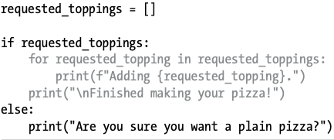

18. Using Multiple Lists
- Validate user input by comparing two lists.
if topping in available_toppings:
print(f"Adding {topping}.")
else:
print("We don't have that topping.")

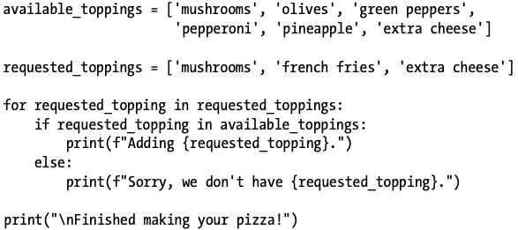

19. Style Guidelines (PEP 8)
- Use spaces around comparison operators.
✅ if age < 4:
❌ if age<4:

20. Key Takeaways
- Conditional tests always return True or False.
- Use:
  - if → one condition
  - if-else → two outcomes
  - if-elif-else → multiple exclusive outcomes
  - Multiple if → multiple actions
- Combine if statements with lists for powerful logic.
- Clean styling improves readability.

